INTERNET TECHNOLOGY LAB

LAB REPORT

NAME: SOHAM LAHIRI

CLASS: BCSE UG-III 6TH SEMESTER

ROLL NO: 002210501107

GROUP: A3

SUBMISSION DATE: 23/04/2025

INDEX

Contents | Page No.
Assignment-1
Assignment-2
Assignment-3
Assignment-4

Assignment 1

Problem Statement: Implementation of Multi client Chat Server
Theory:

In today’s world of digital communication, real-time chat applications are essential. However, most open communication platforms lack proper security, user authentication, and support for file sharing in a peer-based system. The goal is to develop a secure GUI-based chat client that supports:
- Secure encrypted messaging
- User authentication (login system)
- File sharing under 1MB
- Support for direct (user-to-user) and broadcast messaging

Solution Approach:

To address this, we designed a client-server application with the following core features:
- A login interface where users enter credentials
- Chat window for real-time encrypted message exchange
- File transfer capability (up to 1MB)
- Message encryption using Fernet from the cryptography library
- Clear message formatting with recipient detection
- Multi-threading to ensure smooth GUI updates during communication

Design Pattern:

The application follows the MVC (Model-View-Controller) design pattern:
- Model: Handles socket communication and encryption logic.
- View: Tkinter GUI windows (LoginWindow, ChatClient)
- Controller: Binds user actions (e.g., Send button, File Upload) to logic.
Threading is used to keep message receiving non-blocking and responsive.

Features:
- Login Authentication
- Encrypted Messaging using Fernet
- Direct and Broadcast Messaging
- File Sending (under 1MB)
- Threaded Receiving to Avoid UI Freezing
- Basic Error Handling and Alerts
- Modular GUI (separate login and chat windows)
- Recipient auto-detection for direct messages

Implementation Challenges:

Challenge | Description
Encryption before login | Fernet key is exchanged before credentials are verified. Ideally, it should come after a secure handshake or KDF-based key derivation.
Threading and GUI sync | Ensuring that Text widgets are updated from another thread without causing race conditions.
File handling | Handling both file metadata and file content correctly while using the same socket as for message communication.
Single buffer socket | Ensuring messages and files don’t clash or get truncated due to shared socket usage.

Testing:
- Manual testing with multiple clients
- Tested file upload of different sizes (limit: 1MB)
- Tested empty message rejection
- Validated correct recipient handling for username:message format
- Handled server disconnection and graceful exit

Flow Chart:
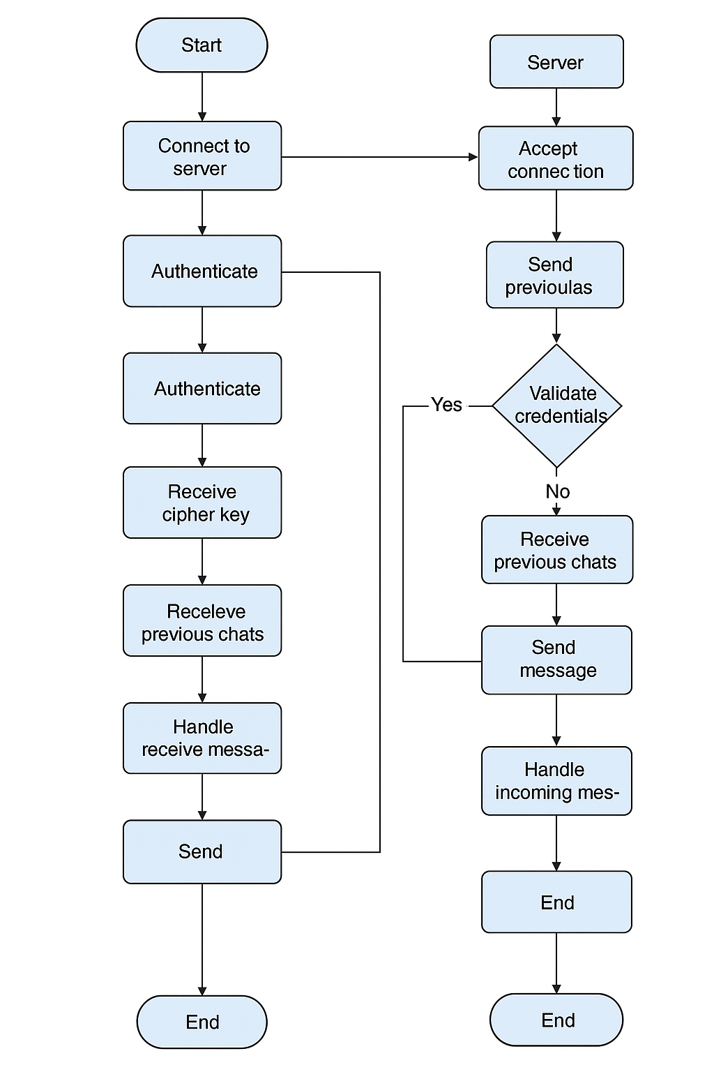

Code:

Server:
Import socket
import threading
import sqlite3
from tkinter import Tk, Label, Button, Listbox, Entry, END, messagebox
from cryptography.fernet import Fernet
from bcrypt import hashpw, gensalt, checkpw
import os
# Server Configuration
HOST = '127.0.0.1'
PORT = 12346
MAX_FILE_SIZE = 1024 * 1024 # 1MB limit
clients = {} # {client_socket: username}
usernames = {} # {username: client_socket}
cipher_key = Fernet.generate_key()
cipher = Fernet(cipher_key)
def init_db():
conn = sqlite3.connect("chat.db")
cursor = conn.cursor()
cursor.execute("""
CREATE TABLE IF NOT EXISTS users (
username TEXT PRIMARY KEY,
password TEXT
)
""")
cursor.execute("""
CREATE TABLE IF NOT EXISTS messages (
sender TEXT,
recipient TEXT,
message TEXT,
timestamp DATETIME DEFAULT CURRENT_TIMESTAMP
)
""")
cursor.execute("""
CREATE TABLE IF NOT EXISTS files (
sender TEXT,
recipient TEXT,
filename TEXT,
data BLOB,
timestamp DATETIME DEFAULT CURRENT_TIMESTAMP
)
""")
conn.commit()
conn.close()
def save_message(sender, recipient, message):
conn = sqlite3.connect("chat.db")
cursor = conn.cursor()
cursor.execute("INSERT INTO messages (sender, recipient, message) VALUES (?, ?, ?)", (sender, recipient, message))
conn.commit()
conn.close()
def save_file(sender, recipient, filename, data):
conn = sqlite3.connect("chat.db")
cursor = conn.cursor()
cursor.execute("INSERT INTO files (sender, recipient, filename, data) VALUES (?, ?, ?, ?)", (sender, recipient, filename, data))
conn.commit()
conn.close()
def get_previous_chats(username):
conn = sqlite3.connect("chat.db")
cursor = conn.cursor()
cursor.execute("""
SELECT sender, recipient, message, timestamp FROM messages
WHERE sender = ? OR recipient = ?
ORDER BY timestamp ASC
""", (username, username))
messages = cursor.fetchall()
conn.close()
return messages
def broadcast(message, recipient=None, sender=None):
"""Send a message to a specific recipient or broadcast to all clients."""
if recipient:
target_client = usernames.get(recipient)
if target_client:
try:
target_client.send(message)
except:
remove_client(target_client)
else:
for client in clients:
if client != sender:
try:
client.send(message)
except:
remove_client(client)
def authenticate_user(client):
"""Authenticate or register a user."""
client.send("AUTH".encode())
creds = client.recv(1024).decode().split(":")
username, password = creds[0], creds[1]
conn = sqlite3.connect("chat.db")
cursor = conn.cursor()
cursor.execute("SELECT password FROM users WHERE username = ?", (username,))
result = cursor.fetchone()
if result:
if checkpw(password.encode(), result[0].encode()):
return username
else:
client.send("INVALID".encode())
return None
else:
hashed_pw = hashpw(password.encode(), gensalt()).decode()
cursor.execute("INSERT INTO users (username, password) VALUES (?, ?)", (username, hashed_pw))
conn.commit()
return username
def handle_file_transfer(client, username):
"""Handle file transfer from client."""
try:
# Receive file information: recipient:filename:filesize
file_info = cipher.decrypt(client.recv(1024)).decode().split(":", 2) # Split recipient and filename
if len(file_info) != 3:
print(f"Invalid file info received from {username}")
return
recipient, filename, filesize_str = file_info
filesize = int(filesize_str)
if filesize > MAX_FILE_SIZE:
client.send(cipher.encrypt("FILE_TOO_LARGE".encode()))
return
# Receive file data
file_data = client.recv(filesize)
if len(file_data) != filesize:
print(f"Incomplete file received from {username}")
return
save_file(username, recipient, filename, file_data) # Save the file to the database
broadcast(cipher.encrypt(f"{username} sent a file '{filename}' to {recipient}".encode()), recipient=recipient) # Notify recipient
except Exception as e:
print(f"File transfer error: {e}")
def handle_client(client):
try:
client.send(cipher_key)
username = authenticate_user(client)
if username:
# Send previous chat messages
previous_chats = get_previous_chats(username)
for sender, recipient, message, timestamp in previous_chats:
formatted_message = f"{sender} (to {recipient}): {message}"
client.send(cipher.encrypt(formatted_message.encode()))
usernames[username] = client
clients[client] = username
broadcast(cipher.encrypt(f"{username} joined the chat.".encode()))
while True:
encrypted_message = client.recv(1024)
if not encrypted_message:
break # Client disconnected
message = cipher.decrypt(encrypted_message).decode()
if message.startswith("FILE:"): # Check if the message is a file transfer request
threading.Thread(target=handle_file_transfer, args=(client, username), daemon=True).start()
continue # Skip normal message handling
if ":" in message:
recipient, msg = message.split(":", 1)
broadcast(cipher.encrypt(f"{username} (to {recipient}): {msg}".encode()), recipient=recipient)
save_message(username, recipient, msg) # Save private message
else:
broadcast(cipher.encrypt(f"{username}: {message}".encode()), sender=client)
save_message(username, "all", message) # Save broadcast message
else:
client.close()
except Exception as e:
print(f"Error in handle_client: {e}")
remove_client(client)

def remove_client(client):
"""Remove a disconnected client."""
if client in clients:
username = clients.pop(client)
usernames.pop(username, None)
broadcast(cipher.encrypt(f"{username} has left the chat.".encode()))
client.close()
class ServerGUI:
def __init__(self, root):
self.root = root
self.root.title("Chat Server")
self.status_label = Label(root, text="Server is stopped.")
self.status_label.pack()
self.client_list = Listbox(root)
self.client_list.pack()
self.start_button = Button(root, text="Start Server", command=self.start_server)
self.start_button.pack()
self.stop_button = Button(root, text="Stop Server", command=self.stop_server, state="disabled")
self.stop_button.pack()
self.message_entry = Entry(root)
self.message_entry.pack()
self.broadcast_button = Button(root, text="Broadcast Message", command=self.broadcast_message)
self.broadcast_button.pack()
self.server_socket = None
self.is_running = False
def start_server(self):
"""Start the server."""
self.server_socket = socket.socket(socket.AF_INET, socket.SOCK_STREAM)
self.server_socket.bind((HOST, PORT))
self.server_socket.listen()
self.is_running = True
self.status_label.config(text="Server is running...")
self.start_button.config(state="disabled")
self.stop_button.config(state="normal")
threading.Thread(target=self.accept_clients, daemon=True).start()
def stop_server(self):
"""Stop the server."""
self.is_running = False
if self.server_socket:
self.server_socket.close()
self.status_label.config(text="Server is stopped.")
self.start_button.config(state="normal")
self.stop_button.config(state="disabled")
def accept_clients(self):
"""Accept new client connections."""
while self.is_running:
try:
client, addr = self.server_socket.accept()
self.client_list.insert(END, f"{addr}")
threading.Thread(target=handle_client, args=(client,), daemon=True).start()
except:
break
def broadcast_message(self):
"""Send a broadcast message from the server."""
message = self.message_entry.get().strip()
if message:
broadcast(cipher.encrypt(f"SERVER: {message}".encode()))
self.message_entry.delete(0, END)
else:
messagebox.showwarning("Warning", "Message cannot be empty!")
if __name__ == "__main__":
init_db()
root = Tk()
server_gui = ServerGUI(root)
root.mainloop()

Client:
import socket
import threading
from tkinter import Tk, Toplevel, Text, Entry, Button, Scrollbar, messagebox, Label, END, filedialog
from cryptography.fernet import Fernet
import os
# Server Configuration
HOST = '127.0.0.1'
PORT = 12346
class ChatClient:
def __init__(self, root, client_socket, cipher, username):
self.root = root
self.root.title("Chat Client - {}".format(username)) # Display username in title
self.chat_display = Text(root, state="disabled", height=20, width=50)
self.chat_display.pack()
scrollbar = Scrollbar(root, command=self.chat_display.yview)
scrollbar.pack(side="right", fill="y")
self.chat_display["yscrollcommand"] = scrollbar.set
self.message_entry = Entry(root)
self.message_entry.pack()
self.send_button = Button(root, text="Send", command=self.send_message)
self.send_button.pack()
self.send_file_button = Button(root, text="Send File", command=self.send_file)
self.send_file_button.pack()
self.client_socket = client_socket
self.cipher = cipher
self.username = username # Store the username
self.recipient = None # Add recipient attribute
threading.Thread(target=self.receive_messages, daemon=True).start()
def send_message(self):
"""Send a message."""
message = self.message_entry.get().strip()
if message:
# Check if the message is a direct message
if ":" in message:
self.recipient = message.split(":")[0] # Extract recipient from message
try:
self.client_socket.send(self.cipher.encrypt(message.encode()))
self.message_entry.delete(0, END)
except Exception as e:
messagebox.showerror("Error", f"Failed to send message: {e}") # More specific error
else:
messagebox.showwarning("Warning", "Message cannot be empty!")
def send_file(self):
"""Send a file."""
filename = filedialog.askopenfilename(initialdir=".", title="Select a File")
if filename:
try:
filesize = os.path.getsize(filename)
if filesize > 1024 * 1024:
messagebox.showerror("Error", "File size exceeds 1MB limit.")
return
with open(filename, "rb") as file:
file_data = file.read()
# Get recipient
recipient = self.recipient if self.recipient else "all" # Default to all if no recipient
# Send file information: recipient:filename:filesize
file_info = f"{recipient}:{os.path.basename(filename)}:{filesize}"
self.client_socket.send(self.cipher.encrypt(f"FILE:{file_info}".encode())) # Prefix with "FILE:"
# Send file data
self.client_socket.send(file_data)
messagebox.showinfo("Info", f"File '{os.path.basename(filename)}' sent successfully.")
except Exception as e:
messagebox.showerror("Error", f"Failed to send file: {e}")
def receive_messages(self):
"""Receive messages."""
while True:
try:
encrypted_message = self.client_socket.recv(1024)
if not encrypted_message: # Handle disconnection
break
message = self.cipher.decrypt(encrypted_message).decode()
self.chat_display.config(state="normal")
self.chat_display.insert(END, f"{message}\n")
self.chat_display.config(state="disabled")
self.chat_display.see(END)
except Exception as e:
print(f"Error receiving message: {e}") # Print error for debugging
break # Exit loop on error
self.close_connection() # Call close_connection on error or disconnection
def close_connection(self):
"""Close the connection to the server."""
try:
self.client_socket.close()
exce
pt Exception as e:
print(f"Error closing connection: {e}")
messagebox.showinfo("Info", "Disconnected from server.")
self.root.destroy() # Close the chat window
class LoginWindow:
def __init__(self, root):
self.root = root
self.root.title("Login")
Label(root, text="Username:").pack()
self.username_entry = Entry(root)
self.username_entry.pack()
Label(root, text="Password:").pack()
self.password_entry = Entry(root, show="*")
self.password_entry.pack()
self.login_button = Button(root, text="Login", command=self.authenticate)
self.login_button.pack()
self.client_socket = None
self.cipher = None
self.username = None # Store the username
def connect_to_server(self):
"""Connect to the server."""
try:
self.client_socket = socket.socket(socket.AF_INET, socket.SOCK_STREAM)
self.client_socket.connect((HOST, PORT))
# Receive encryption key
key = self.client_socket.recv(1024)
self.cipher = Fernet(key)
except Exception as e:
messagebox.showerror("Error", f"Connection failed: {e}")
self.root.quit()
def authenticate(self):
"""Authenticate the user."""
username = self.username_entry.get().strip()
password = self.password_entry.get().strip()
self.username = username # Store username
if not username or not password:
messagebox.showwarning("Warning", "Both fields are required!")
return
try:
self.client_socket.send(f"{username}:{password}".encode())
response = self.client_socket.recv(1024).decode()
if response == "INVALID":
messagebox.showerror("Error", "Invalid credentials!")
else:
messagebox.showinfo("Success", "Login successful!")
self.root.destroy()
main_window = Tk()
chat_client = ChatClient(main_window, self.client_socket, self.cipher, username)
main_window.protocol("WM_DELETE_WINDOW", chat_client.close_connection) # Handle window close
main_window.mainloop()
except Exception as e:
messagebox.showerror("Error", f"Authentication failed: {e}")
if __name__ == "__main__":
root = Tk()
login = LoginWindow(root)
login.connect_to_server()
root.mainloop()

Output:
